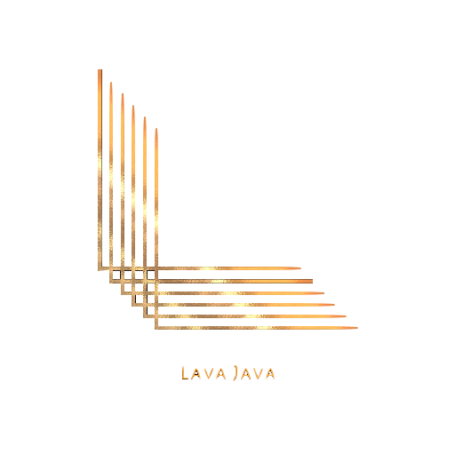

**Names:** Fares Osama, Manar Adel, Zeina Mohamed, Amr Ezzat

*Table of Contents*

What is Lava Java? 3

What did we use to build this website? 3

Tasks Across The Group: 3

Screenshots of our running website: 4

Database: 7

References Used: 7

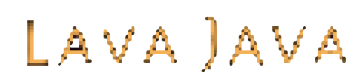

# **What is Lava Java?**

A restaurant dedicated to our Spanish food lovers here in Alexandria. We have built this website for easier access to our restaurant, where you get to do sign in as a user, book reservations, check out our delicious menu, and even order delivery right to your door step.

# **What did we use to build this website?**

We used HTML, CSS, JS, PHP, and MySQL to build the project. This project was all coded using VsCode, and the database was created using PHPMyAdmin.

# **Tasks Across The Group:**

1. *HTML and CSS:*

Fares Osama: Sign in, Sign Out, delivery

Manar Adel: Home, menu, food

Zeina Mohamed: offers, reservation, feedback

Amr Ezzat: desserts, about , beverages

1. *JavaScript:*

Fares Osama: sign in

Manar Adel: sign up,feedback

Zeina Mohamed: delivery,feedback

Amr Ezzat: reservation

1. *PHP:*

Fares Osama: Sign in

Manar Adel: Sign up, feedback

Zeina Mohamed: Delivery

Amr Ezzat: reservation

# **Screenshots of our running website:**

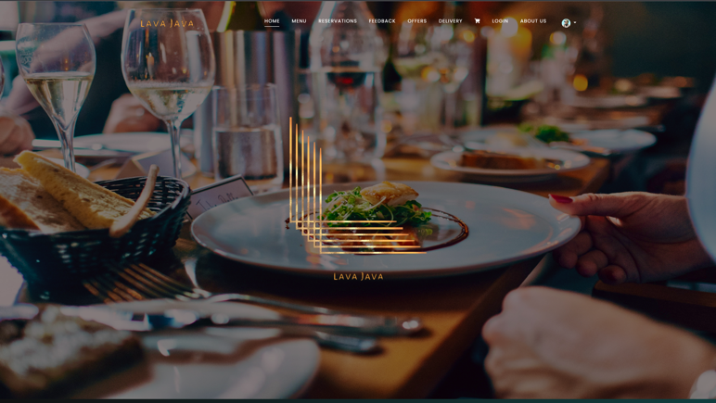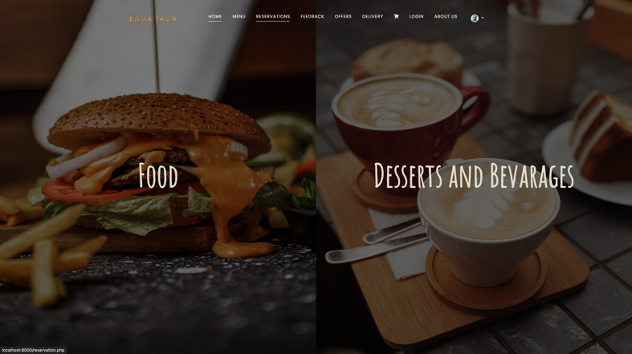-Home Page: -Menu:

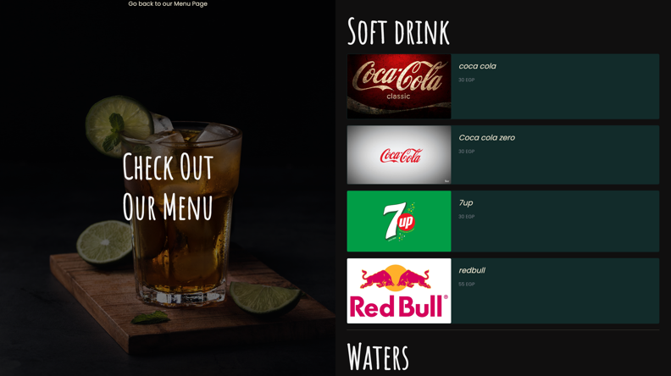-Food: -Beverages:

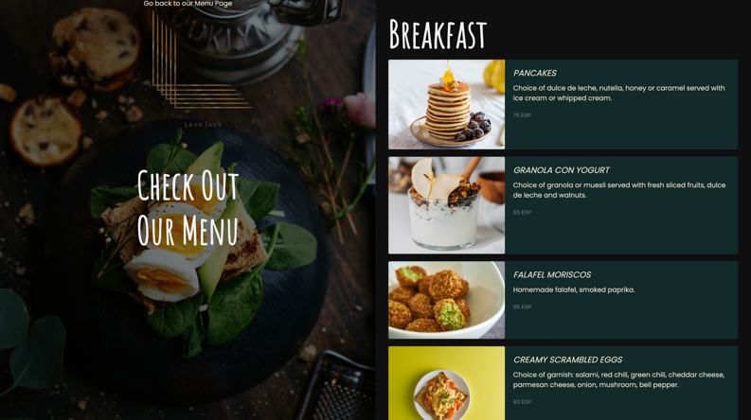

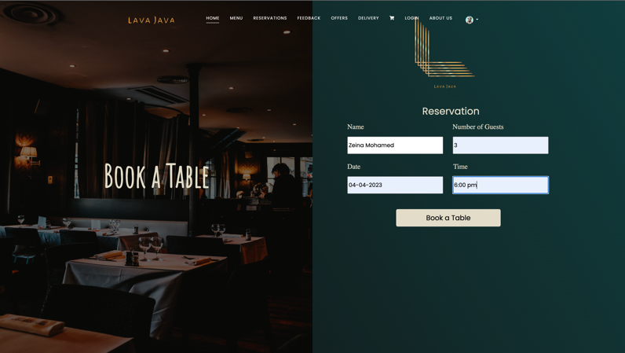-Offers: -Reservation:

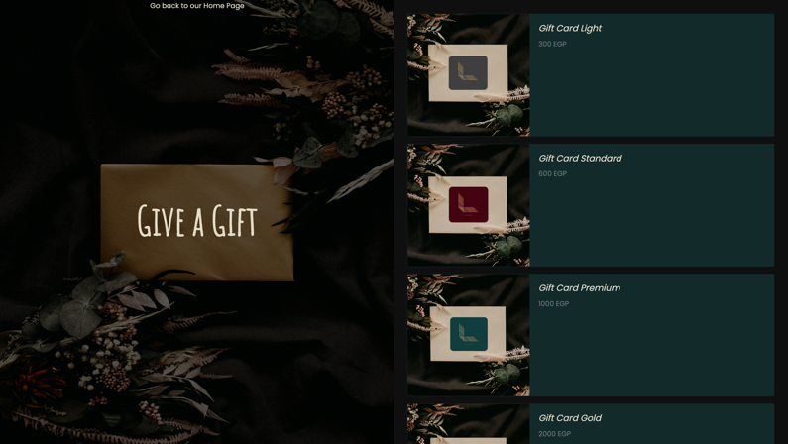

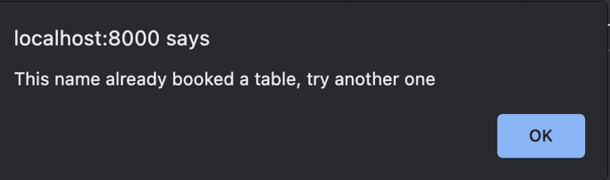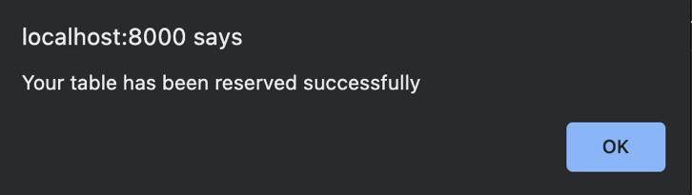 -Booking a reservation: -Booking another table under the same name:

-Feedback: -Submitting feedback:

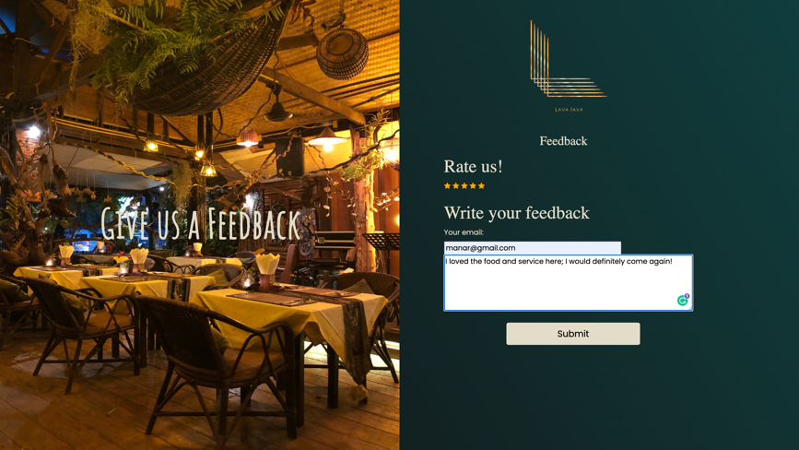

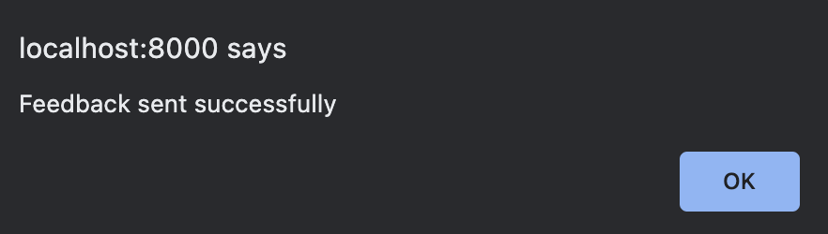

-Submitting feedback without a signup email: -Sign Up:

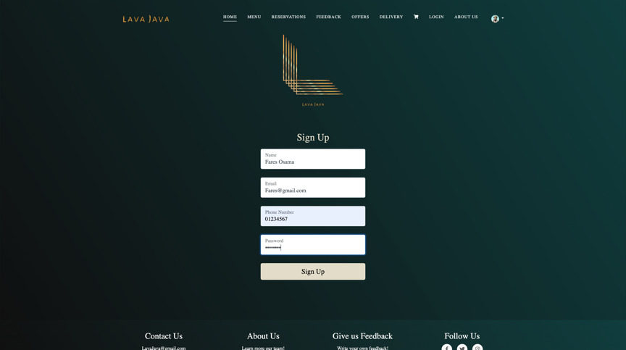

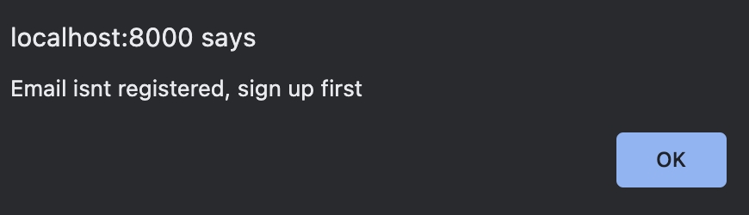

-Creating an account: -Sign In with Cookies:

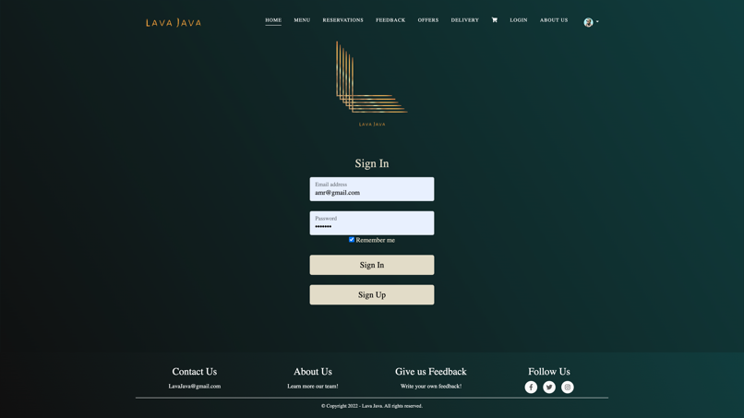

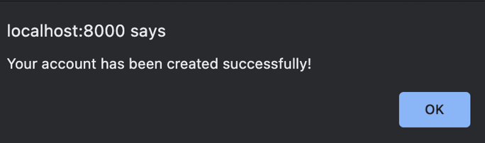

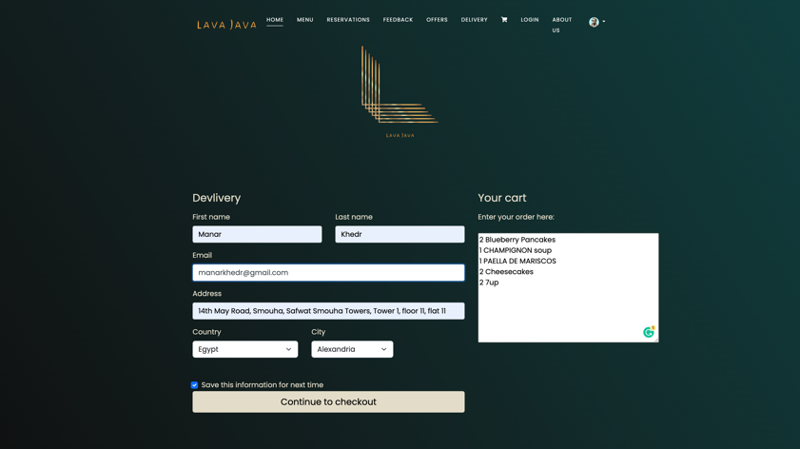-About: -Delivery:

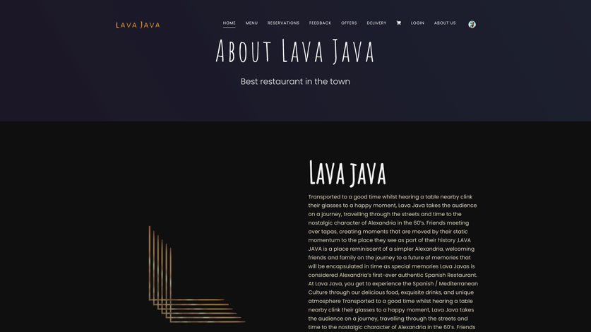

-Submitting an Order:

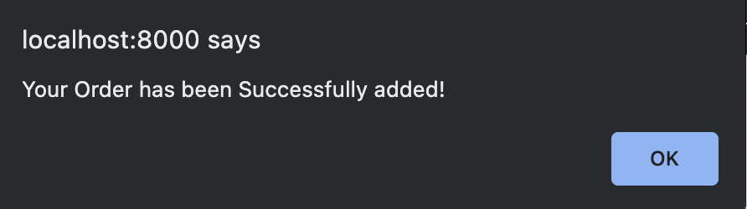

# **Database:**

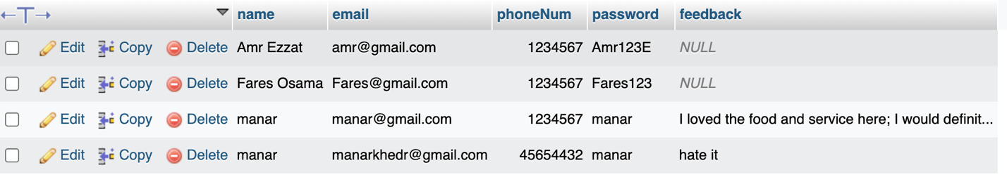

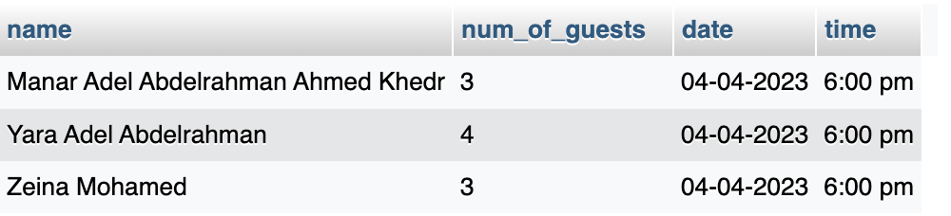

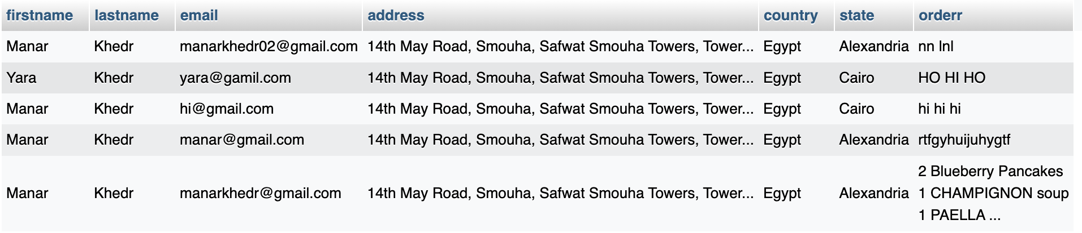

# **References Used:**

***Helpful Links:***

<https://www.appbrewery.co/p/web-development-course-resources/>

***Color:***

<https://colorhunt.co>

***Color Palate:***

<https://colorhunt.co/palette/100f0f0f3d3ee2dcc8f1f1f1>

***Logo:***

<https://www.brandcrowd.com/maker/logos?Text=food&SearchText&wizardContinue>

***Pictures:***

<https://unsplash.com/s/photos/food>

<https://www.pexels.com/>

***Template:***

<https://webflow.com/templates/html/nique-restaurant-website-template>

<https://preview.webflow.com/preview/nique-template?utm_medium=preview_link&utm_source=designer&utm_content=nique-template&preview=61dd24cb23acafaf53d97c9d07c9d972&pageId=63287b2e20c6944a08557998&itemId=63287b2e20c694069c5579b7&workflow=preview>

***Menu:***

<https://jeedas.com/menu/>

**Fonts and Sizes**:

Headers: <https://fonts.google.com/specimen/Playfair+Display>

Paragraphs: <https://fonts.google.com/specimen/Anonymous+Pro>

Titles/Footers: <https://fonts.google.com/specimen/Amatic+SC>